34.114: a) From the figure, 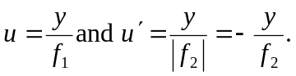
So the angular magnification is: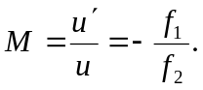
b) 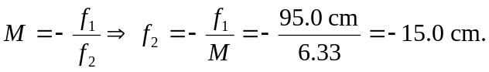
c) The length of the telescope is 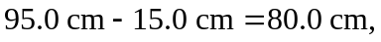compared to the
length of 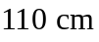for the telescope in Ex. 34.55.

